**Instructions for adding an email template macro to an Excel File**

**Mark Depathy, MSM**

1. Enable the developer tab in Excel:

**How to add Developer tab into Excel 2007 Ribbon?**

* Click the **Office Button**;
* Click the **Excel Option** button at the bottom, then you will enter the Excel Option window;
* Click the **Popular** button at the left;
* Under Top Option for Working with Excel, check the **Show Developer tab in the Ribbon** option.
* Click **Ok** button to finish editing.

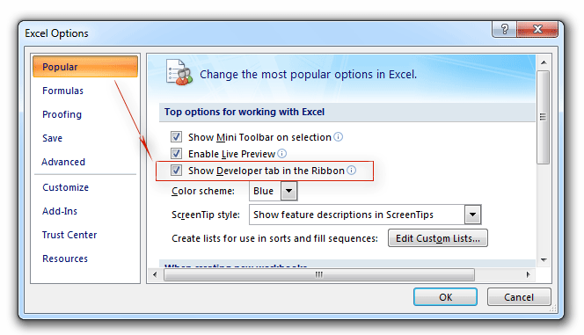

1. Next, on the Developer tab, click on “Visual Basic”

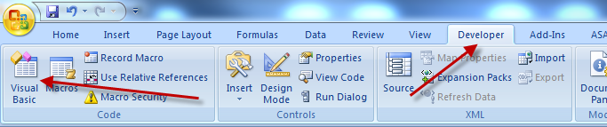

1. Next, Right click on “This workbook” and Click “View Code”

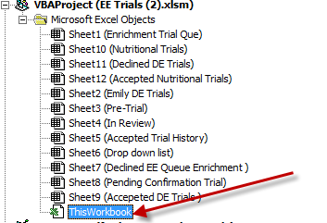

**Next, Paste this code below in the Right Pane/Window:**

Private Sub Workbook_BeforeSave(ByVal SaveAsUI As Boolean, Cancel As Boolean)

Dim myolapp As Object

Dim myitem As Object

Set myolapp = CreateObject("Outlook.Application")

myolapp.Session.Logon

Set myitem = myolapp.CreateItemFromTemplate("\\cifs2\ratech$\Non-Human Primates\ENRICHMENT\NHP Environmental Enrichment\EE Trials\Email-Template\EE-Trials.oft")

myitem.Display 'or send

End Sub

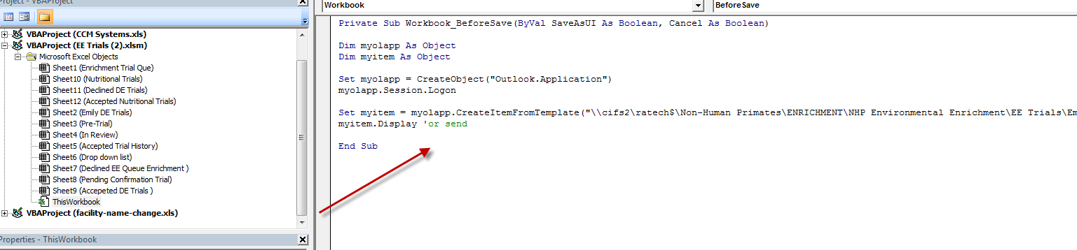

Now Save and Close this Window and Save the Workbook.

If you want a different email template, just edit the Path in the line below.

**Set myitem = myolapp.CreateItemFromTemplate("****\\cifs2\ratech$\Non-Human Primates\ENRICHMENT\NHP Environmental Enrichment\EE Trials\Email-Template\EE-Trials.oft****")**

Thanks,

Mark